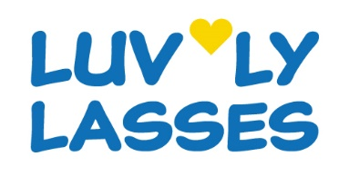
MEMBERSHIP APPLICATION PLEASE COMPLETE IN BLOCK CAPITALS ANNUAL SUBSCRIPTION £36 PAYABLE PRO RATA AT £3 PER CALENDAR MONTH
Date joined: |  |  | Amount Paid £ |  | Membership valid, from: / until: /
Title: | MISS | MRS |  | MS | Other:
First Name: |  |  |  |  |  |  | Middle Name:
Surname:
House Name or Number:
Address Line 1:
Address Line 2:
Address Line 3:
Post Town: |  |  |  |  |  |  |  | Postcode:
Contact Tel No:
Email address:
Please provide contact details for use in the event of an emergency
Emergency Contact Name: |  |  |  |  |  | Emergency Tel No:
As part of your membership Luv’ly Lasses will store and use your name, address, telephone number and email address to keep you informed of our events and activities. We will protect your data, using it safely and responsibly and will not reveal it to any external parties or within our organisation beyond the requirements of reasonable communication. Luv’ly Lasses will take photographs during the course of our activities and events, which will only be used in our closed, members only Facebook group or in other internal communications and will not be shared beyond our group. We take your privacy and security very seriously, however if you do not consent to your photograph being used in this way please tick the box □
If you have any additional or special needs that you feel we should be aware of please share them here:

Please tell us anything else about yourself that will help us to make Luv’ly Lasses brilliant. For example do you have any special skills or talents you could share, or interests you’d love to learn more about?

Luv'ly Lasses is committed to safeguard and promote the welfare, health (including mental health) and safety of all members by creating and maintaining an open, safe, caring and supportive atmosphere. Safeguarding is recognised as the responsibility of all members. Please sign this document as acknowledgement that you accept our group’s values and that you will uphold and support the principles of our constitution which is based on mutual kindness and respect.
Name Printed: |  |  |  |  |  | Signed:
Luv’ly Lasses reserve the right to refuse membership

